Daniel Thomsen

CS-313

Project Proposal : CIT Help Lab Queue

Product Description
The purpose of this project is to create a help lab Queue, similar to the Computer Science help lab queue, though, with a few extra nice features. This Lab is to simplify the lab assistants ability to assist students without looking the room over every five minutes to see if a hand is in the air, or create a whiteboard list that neither lab assistant can whether an individual has been assisted yet or not, or if a lab assistant is currently assisting a student.

Design Overview
To begin, the whole lab queue will consist of three HTML/PHP pages, not including CSS or any possible external PHP pages that are to handle the back-end of the site. This is purely meant for the lab assistants and the students.

The first will be what the average student will see.
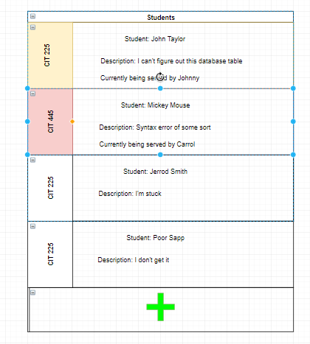
It is fairly simple and will act the way that most queue's behave, where the individual at the top will be served first, all the way to the last person, with the ability of course, for more students to jump on the queue. This will be both mobile and desktop friendly. The only information that a student will out in is their name, their course code, which will probably be chosen from a list of pre-chosen courses, and a brief description (no more than 100 or so characters). This information will be stored temporarily on the queue. Each student will be automatically assigned to a Lab assistant as the lab assistant becomes available. The only individuals allowed to remove themselves from the list are the same students who signed up on the lab and the lab assistants.

The next page is a page that only the lab assistants will see, which is overall similar, but mobile only and will have a few key differences, mainly, the ability to remove any individual from the queue and the ability to skip helping specific people as necessary.

Lab assistants data will be saved in the database, which will see what classes the lab assistant will be able to assist students with. That way a lab assistant who is not skilled in a higher level CIT course will never be assigned to a student requesting help for that course.

The last web page will also only be for lab assistants. It will be for lab assistants to log into. There is no “sign up page” as that will create a whole other issue with teacher verification and approval that I feel is outside of the scope of this project.

Database
There will be mainly be three tables in the data base. The first table will be for any permanent information that will be present no matter who the lab assistants are or the students using it. Mainly just the course code/course title.

The second will be for semi-permanent data – This information is information on the Lab assistants. It will be stored in the database for as long as a lab assistant is working in that capacity with the CIT department. It will include the name of the lab assistant and which courses the lab assistant can assist with.

The third will be for temporary storage – this information includes only what the name of the student is that's asking for assistance, the course that student belongs to, and the brief description of the issue at hand.

The only shared information between these tables will be the courses.

Another possibility of information to be stored is that of time and the names of students asking for help, so that the professors can see which students are struggling the most, and which students are overusing the lab assistants or if lab assistants may need more help if one is being forced to spend too much time with students on average.

Database retrieval
As information is constantly getting added by the queue by students that, information must be displayed for the lab assistants to see, so such information retrieved by the data base will be the name, course and description of problem of each student submitting requests.

Database Update
This information might include allowing lab assistants to change courses that assistants can help with and the average time spent with each student.

